

**Business Rules Specification (BRS)**

**For**

**Supply, Installation, Configuration and Customization/Development of Core Insurance, Call Center & Customer Relationship Management, Business Intelligence and Web Portal & Content Management System applications for Jiban Bima Corporation and Sadharan Bima Corporation**

**BISDP-G10 BRS Volume 2 - SBC**

**Submitted to**



**Insurance Development and Regulatory Authority (IDRA),**

**represented by the Project Director, Bangladesh Insurance**

**Sector Development Project**

**Submitted by**

Sinosoft Co.,Ltd

Document ID: Sinosoft/BISDP-G10 BRS Vol.2 - SBC

Date of Release: 5th April 2023

Version: V – 1.0

**Submitted by**

Sinosoft Co.,Ltd

Document ID: Sinosoft/BISDP-G10 BRS Vol.2 - SBC

Date of Release: 28th November 2022

Version: V - 1.1

|  |  |
| --- | --- |
| **Document Name:** | **Business Rules Specification (BRS) [ Volume 2 - Sadharan Bima Corporation (SBC)] of Supply, Installation, Configuration and Customization/Development of Core Insurance, Call center & Customer Relationship Management, Business Intelligence and Web Portal & Content Management System applications for Jiban Bima Corporation and Sadharan Bima Corporation** |
| **Document ID:** | **Sinosoft/BISDP-G10 BRS Vol.2 - SBC** |
| **Version:** | **1.0** |
| **Submission Date:** | **18 April, 2023** |
| **Submitted by:** |  |
| **Approved by:** |  |

Submission & Approval

Document Release History

The following table lists the release history of this document.

|  |  |  |  |  |  |  |
| --- | --- | --- | --- | --- | --- | --- |
| Sl. No. | Version Number | Release Date | Prepared By | Reviewed By | Approved By | Reasons for Release |
| 1. | 1.0 | 05-Apr-2023 | Sinosoft Co., Ltd. |  |  |  |

Contents

Submission & Approval 2

Document Release History 3

Document Revision History 6

Document Acceptance Sign Off 7

1. Introduction 8

1.1. Purpose of Document 8

1.2. Stakeholders 8

1.3. Glossary of Terms 9

2. Business Goals / Objective 10

2.1. Business Problem / Opportunity 10

2.2. Business Objectives / Benefits 10

3. Scope 10

3.1. In Scope 10

3.2. Out of Scope 11

4. Business Process 11

5. Product Definition 12

5.1. Product Basic Information 12

5.2. Product List 12

5.3. Item Attributes 13

5.4. Product Features 13

5.5. Clause Attributes 13

5.6. Clause Wording File 19

5.7. Product Memo 19

6. Business Rules 19

7. Pricing/Premium Calculations 20

7.1. New Policy Pricing Structure / Premium Calculation 20

7.2. Premium Rate 20

7.3. Additional Policy 20

7.4. Government Service VAT 20

7.5. Financially Impacted Endorsements Premium Formula / Calculation 21

8. New Business For Underwriting 21

8.1. Underwriting Rules 21

8.2. Underwriting Workflow 22

8.3. Endorsement 22

9. Claim 22

9.1. Claim Rules 22

9.2. Claim Workflow 23

10. BCP(Billing Collection & Payment) 23

11. Policy Documents 24

11.1. Policy Summary (Schedule) 24

11.2. Insurance Contract (Policy Wording) 24

11.3. Debit Note 24

Business Requirements Specification

**Direct Business For Motor Insurance Product**

**Version 1.0**

|  |
| --- |
| Statement of Confidentiality  This document contains information that is proprietary and confidential to Sadharon Bima Corporation, which shall not be disclosed, transmitted, duplicated, or used in whole or in part for any function other than its intended purpose. Any use or disclosure in whole or in part of this information without explicit written permission of Sadharon Bima Corporation is prohibited.  © Copyright, Sadharon Bima Corporation |

**Document Control**

# Document Revision History

|  |  |  |  |
| --- | --- | --- | --- |
| Version No. | Date  (dd mm yyyy) | Author(s) | Revision Description |
| V- 1.0 | 05-04-23 | Mamun | Final Version |
|  |  |  |  |

***Table1: Document Revision History***

**Review and Acceptance Sign Off**

# Document Acceptance Sign Off

This document was reviewed & signed off by:

|  |  |  |  |
| --- | --- | --- | --- |
| Name | Department / Authorization | E-Signature  (Email Sign Off) | Date Sign Off Received  (dd mmm yyyy) |
|  |  |  |  |
|  |  |  |  |
|  |  |  |  |
|  |  |  |  |
|  |  |  |  |
|  |  |  |  |
|  |  |  |  |
|  |  |  |  |
|  |  |  |  |
|  |  |  |  |
|  |  |  |  |
|  |  |  |  |
|  |  |  |  |
|  |  |  |  |
|  |  |  |  |
|  |  |  |  |
|  |  |  |  |
|  |  |  |  |
|  |  |  |  |
|  |  |  |  |
|  |  |  |  |
|  |  |  |  |

***Table2: Document Acceptance Sign Off***

# Introduction

## Purpose of Document

The Business Requirements Document (BRS) describes the product design, specifications, and general operational guidelines of an individual business product, Non-Life Insurance, to be launched as part of the suite of products for Sadharon Bima Corporation in Bangladesh. This document collates all the business requirements of different stakeholders for the system to be developed in conjunction with this product launch.

## Stakeholders

This document’s stakeholders from business and IT teams who either contributed to the requirements or will need to refer to the same as the project goes.

| **#** | **Business Units / Departments / Roles** | **Name** |
| --- | --- | --- |
| 1 |  |  |
| 2 |  |  |
| 3 |  |  |
| 4 |  |  |
| 5 |  |  |
| 6 |  |  |
| 7 |  |  |
| 8 |  |  |
| 9 |  |  |
| 10 |  |  |
| 11 |  |  |
| 12 |  |  |
| 13 |  |  |
| 14 |  |  |
| 15 |  |  |
| 16 |  |  |
| 17 |  |  |
| 18 |  |  |
| 19 |  |  |
| 20 |  |  |
| 21 |  |  |
| 22 |  |  |
| 23 |  |  |
| 24 |  |  |
| 25 |  |  |
| 26 |  |  |
| 27 |  |  |
| 28 |  |  |

***Table3: Target Audience***

## Glossary of Terms

Words, abbreviations, or terminologies that may be widely used by the insurance industry and IT department but is not common to layman terms and thereby need to be specified to allow all readers of this document to understand the same.

| **#** | **Item** | **Definition** |
| --- | --- | --- |
| 1 | D2C | Direct To Client |
| 2 | Condo | Condominiums |
| 4 | BIE | Basic Information Endorsement |
| 5 | POI | Period Of Insurance |
| 6 | NOL | Notice Of Loss |
| 7 | CP | Customer Portal |
| 8 | CRM | Customer Relationship Management |
| 9 | SI | Sum Insured |
| 10 | Bldg | Building |
| 11 | Reno | Renovation |
| 12 | SCB | Standard Charter Bank of Singapore |
| 13 | DBS | Development Bank of Singapore |
| 14 | DMS | Document Management System |
| 15 | AWPL | Automated Workflow Pte Ltd Vendor of the DMS system that FWD uses |
| 16 | RTM | Requirements Traceability Matrix |
| 17 | BAU | Business As Usual |
| 18 | GST | Government Service Tax |
| 19 | IPP | Instalment Payment Plan |
| 20 | XOL | Excess of Loss |
| 21 | FAQ | Facts and Questions |
| 22 | CSO | Customer Service Officer |
| 23 | POI | Period of Insurance |
| 24 | URL | Uniform Resource Locator / Web Address or Web Link |

***Table4: Glossary of Terms***

# Business Goals / Objective

## Business Problem / Opportunity

In Bangladesh, a large amount of property and business has ownership with a total percentage of approximately 95%. Types of Properties are mainly House, Commercial buildings, Hotel, Powerplants, Aviation Company, Shipping Corporation and Export & Imported goods etc. SBC offers insurance policy for this type of property. The policy offers financial security by covering losses or damages. Currently, there exists several misconceptions on what are being covered by insurances products in the market in terms of property structure and contents. Apart from this, false assumptions are also being made to insurance products and their coverage.With this, the business sees the opportunity to come up with insurance to address the needs of Bangladesh Domestic & Commercial market and provide more clarity to the clients on what are being covered and the detailed benefits they have.

## Business Objectives / Benefits

|  |  |
| --- | --- |
| **Objectives** | **Expected Benefits** |
| Address Market Needs | Address the market needs in the property segment of Bangladesh |
| Increase Business Revenue | Increase overall business revenue by ensuring the company covers the market needs of clients. |

***Table5: Business Objectives / Benefits***

# Scope

This is at business level and process/area scope – not system functionality scope.

## In Scope

| **Business / System Group** | **In-Scope** |
| --- | --- |
| Product Definition | * Product Basic Information * Product List * Item Attribute * Product Features * Clause Attribute * Clause Wording File * Product Memo |
| Pricing/Premium Calculation | * New Policy Premium Calculation Formula * Premium Rate Set * Additional Policy * Government Service VAT * Premium Calculation Formula in Endorsement |
| New Business For Underwriting | * Underwriting Rules * Underwriting Workflow * Endorsement |
| Endorsements | * Backend modifications/cancellations for existing issued policies * Financially Impacted   + BIE, Addition/Deletion of Optional Benefits   + BIE, Change to Sum Insured   + BIE, Addition/Deletion of Riders   + Flat Cancellation   + Mid-Term Cancellation   + Cancellation without Refund   + POI Extension/Shorten * Non-Financially Impacted   + BIE, Change of Policy Holder’s Particulars   + BIE, Change of Policy Holder’s Address |
| Claims | * Claim Rules * Claim Intimation * Claim Workflow Process * Claim Registration * Claim Calculation * Claim Settlement / Approval |
| BCP(Billing Collection & Payment) |  |
| Policy Documents | * Policy Summary(Schedule) * Insurance Contract(Policy Wording) * Debit Note |

***Table6: In Scope***

## Out of Scope

|  |  |
| --- | --- |
| **Business / System Group** | **Out-of-Scope** |
| Reinsurance | * Reinsurance will be done out of this BRS document and is currently not in the scope of this file. It will be handled separately in a new BRS . |

***Table7: Out of Scope***

# Business Process

This is a new GI system launch that will follow the existing Business Line GI products business processes of the company. There are currently no exceptional cases that needs separate business process flow to handle as compared to existing processes. As such, there will be no As-Is Process and To-Be process highlighted in this section.

# Product Definition

## Product Basic Information

|  |  |
| --- | --- |
| **Product Name** | Motor Insurance |
| **Line of Business** | Motor |
| **Product Versioning Date** | Premium Payment Date |
| **Product Effective/Start Date** | N/A |
| **Product Expiry/End Date** | N/A |
| **Insured Type** | Person/ Instuition |
| **Product Insured Object** | Vehicles/Passngers with driver |
| **Policy default POI** | 365 Days |
| **Renewal Flag** | Yes |
| **Days allowed for Renewal Prior Expiry Date** | 30 days |
| **Grace Period of Renewal** | 30 days |
| **Renewal POI** | Follow Last Policy - Update Renewal to 1 year |
| **Co-insurance** | N/A |
| **Reinsurance Inward** | Yes |
| **Multiple Currency** | Yes |
| **Default Currency** | BDT/USD |
| **Payment Method Accepted** | * Bank Card * Cheque * Pay Order * Bank Transfer |

***Table8: Product Basic Information***

## Product List

|  |  |  |
| --- | --- | --- |
| **SL** | **Product List** | **Product Code** |
| 1 | Private Vehicles | MPV |
| 2 | Commercial Vehicles | MCV |
| 3 | Motor Cycle/ Scooter | MMC |
|  | | |

***Table9: Product List***

## Item Attributes

System will support to select item according to insured needed. Each Item will have different Deductible.

|  |  |  |  |  |  |
| --- | --- | --- | --- | --- | --- |
| **SL No.** | **Item/Section** | **Item Code** | **Sum Insured Limit** | **Premium Rate** | **Deductible Limit** |
| 1 | Fire Risk | MI01 | Manual | Manual | Manual |
| 2 | Explosion Risk | MI02 | Manual | Manual | Manual |
| 3 | Self Ignition Risk | MI03 | Manual | Manual | Manual |
| 4 | Lightning Risk | MI04 | Manual | Manual | Manual |
| 5 | Burglary Risk | MI05 | Manual | Manual | Manual |
| 6 | Housebreaking Or Therft Risk | MI06 | Manual | Manual | Manual |
| 7 | Riot and Strike Risk Malicious Acitivity Damage Risk | MI07 | Manual | Manual | Manual |
| 8 | Earthquake (Fire and Shock Damage) | MI08 | Manual | Manual | Manual |
| 9 | Flood & Cyclone Inundation, Hailstorm & Frost | MI09 | Manual | Manual | Manual |
| 10 | Accidental External | MI10 | Manual | Manual | Manual |
| 11 | Transit (ALL) | MI11 | Manual | Manual | Manual |
| 12 | Electrical and Electronic Fitting | MI12 | Manual | Manual | Manual |

***Table10: Item Attribute***

## Product Features

|  |  |  |  |  |
| --- | --- | --- | --- | --- |
| **SL.No** | **Section/Item List** | **Product** | | |
| **MCV** | **MPV** | **MMC** |
| 1 | Fire Risk | √ | √ | √ |
| 2 | Explosion Risk | √ | √ | √ |
| 3 | Self Ignition Risk | √ | √ | √ |
| 4 | Lightning Risk | √ | √ | √ |
| 5 | Burglary Risk | √ | √ | √ |
| 6 | Housebreaking Or Therft Risk | √ | √ | √ |
| 7 | Riot and Strike Risk Malicious Acitivity Damage Risk | O | O | O |
| 8 | Earthquake (Fire and Shock Damage) | O | O | O |
| 9 | Flood & Cyclone Inundation, Hailstorm & Frost | O | O | O |
| 10 | Accidental External | √ | √ | √ |
| 11 | Transit (ALL) | √ | √ | √ |
| 12 | Electrical and Electronic Fitting | O | O | O |

***Table11: Product Features***

## Clause Attributes

System would support to choose clause text from drop down list with clause content. Clause content will be editable. In system there would have “other” option to add Clause & Clause content manually.

|  |  |  |  |
| --- | --- | --- | --- |
| **SL. No** | **Clause Title** | **Clause Code** | **Condition & Rate** |
| 1 | Own damage | MC01 | Manual Input If needed |
| 2 | Compulsory Excess (applicable to Own damage ) | MC02 | Manual Input If needed |
| 3 | Liability To Third Parties | MC03 | Manual Input If needed |
| 4 | Avoidance of certain terms and right of recovery | MC04 | Manual Input If needed |
| 5 | General exceptions Applicable to all section of the Policy | MC05 | Manual Input If needed |
| 6 | Public Place | MC06 | Manual Input If needed |
| 7 | Limitations as to use | MC07 | Manual Input If needed |
| 8 | Driver: Any of the following | MC08 | Manual Input If needed |
| 9 | No Claim Bonus | MC09 | Manual Input If needed |
| 10 | Period of insurance | MC10 | Manual Input If needed |

***Table12: Clause Attribute***

## Clause Wording File

## Product Memo

# Business Rules

|  |  |  |
| --- | --- | --- |
| **SL No.** | **Business Rules** | **Description** |
| 1 | Age Limit | Policy holder must be 18 years or more |
| 2 | Vehicle Fitness Certificate Number or Tax Token Number | Policy holder must have Vehicle Fitness Certificate Number or Tax Token Number |
| 3 | Vehicles Driving License | Policy holder must have Vehicles Driving License Number |
| 4 | Particulars of the vehicle | Policy holder must provide Horse Power or cubic Capacity, year of the Manufacture, type of body, Engine number, Chasis Number infromation. |

# Pricing/Premium Calculations

## New Policy Pricing Structure / Premium Calculation

Formula will configure backend in the system and system supports to calculate automatically according to bellow formula.

New policy formula:

|  |  |  |  |  |  |  |  |  |  |  |  |  |
| --- | --- | --- | --- | --- | --- | --- | --- | --- | --- | --- | --- | --- |
| **SI** |  | **Premium Rate** |  | **Basic** |  | **PD Fee** |  | **VAT(%)** |  | **TPL** |  | **Deductable Risks** |
| Manual | * | From tariff | + | Manual | + | Passenger+Driver fee | + | 15% | + | Optional | + | Optional |

Renawal policy formula:

|  |  |  |  |  |  |  |  |  |  |  |  |  |  |  |
| --- | --- | --- | --- | --- | --- | --- | --- | --- | --- | --- | --- | --- | --- | --- |
| **SI** |  | **Premium Rate** |  | **Basic** |  | **PD Fee** |  | **VAT(%)** |  | **NOC** |  | **TPL** |  | **Deductable Risks** |
| Manual | * | From tariff | + | Manual | + | Passenger+Driver fee | + | 15% | - | Mamual | + | Optional | + | Optional |

***Table13: N.B: For More Clarification go through the Product Memo.***

## Premium Rate

Premium rates are tarrif based.

## Additional Policy

System will support to Issue Additional Policy apart of Master policy.

No additional policy for the motor Product

## Government Service VAT

This product will have a standard rate of 15% VAT charge on the Net Premium.

## Financially Impacted Endorsements Premium Formula / Calculation

Formula will configure backend in the system and system supports to calculate automatically according to below formula.

**Addition/Deletion of Optional Benefits Endorsement.**For this type Endorsement Premium Rate would be manual.

*Remarks:*

* **Sum Insured Increase Formula:**
* **Period Of Insurance Extension/Shorten Formula:**
* **Sum Insured & POI Extend Formula:**

# New Business For Underwriting

## Underwriting Rules

* UW rules are provided by underwriting module and maintained the backend.

|  |  |  |
| --- | --- | --- |
| **#** | **Business Rule** | **Description** |
| 1 | Sum Insured | Sum Insured cross the country limit. |
| 2 | Risks Coverage | Risk coverages exist in tariff or circular. |
| 3 | SBC Higher Authority Approval | SBC RI Underwriting Department has to take approval in this Underwriting process when RI UW Department getting rate from Foreign RI. |

***Table15: Underwriting Rules***

## Underwriting Work-flow

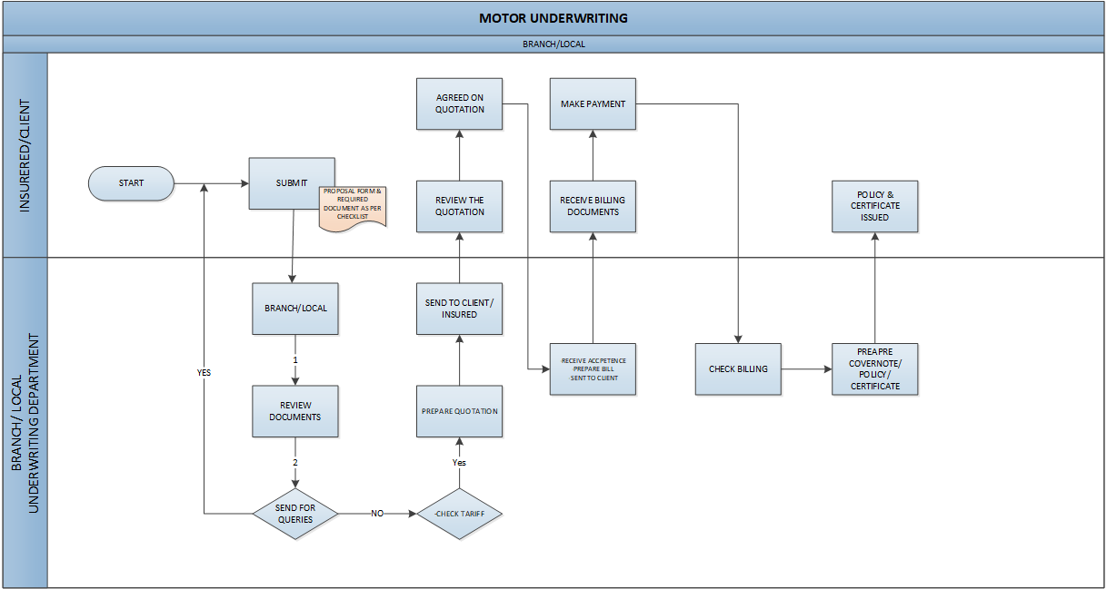

## Endorsement

System supports the following type endorsement.

|  |  |  |  |  |
| --- | --- | --- | --- | --- |
| **Endorsement Type** | **Description** | **Premium Impacting?** | **Permitted to product?** | **Remarks** |
| Basic Information Endorsement | Change of Policy Holder’s Particulars | No | Yes |  |
| Change of Insured Address | No | Yes |  |
| Change of Plan Type | No | No |  |
| Addition/Deletion of Optional Benefits | Yes | Yes |  |
| Change to Sum Insured | Yes | Yes |  |
| Cancellation | Flat Cancellation | Yes | Yes |  |
| Mid-Term Cancellation | Yes | Yes |  |
| Cancellation without Refund | Yes | Yes |  |
| POI Extension/Shorten | Extension - Change the Policy Expiry Date to extend the POI Shorten - Change the Policy Expiry Date to shorten the POI | Yes | Yes | Only Shorten Allow |

***Table16: Endorsement.***

# Claim

## Claim Rules

Module in Sinosoft system that allows business users to be able to do claims register and transactions based on claims from policy holders. This module will also need to be configured accordingly to ensure that it handles claims for product based in the system.

|  |  |  |
| --- | --- | --- |
| **#** | **Claim Rule** | **Description** |
| 1. | Claim Notify Time | Insured/Clients need to notify the claim within claim notify period which is mentioned on policy. |
| 2. | Period Of Insurance | Claim need to happen during insurance period. |
| 3. | Expire Time on Policy | Claim need to happen before expire time on policy. |
| 4. | Premium Payment Clearance | Premium billing must be paid. |

***Table17: Claim Rules.***

## Claim Workflow

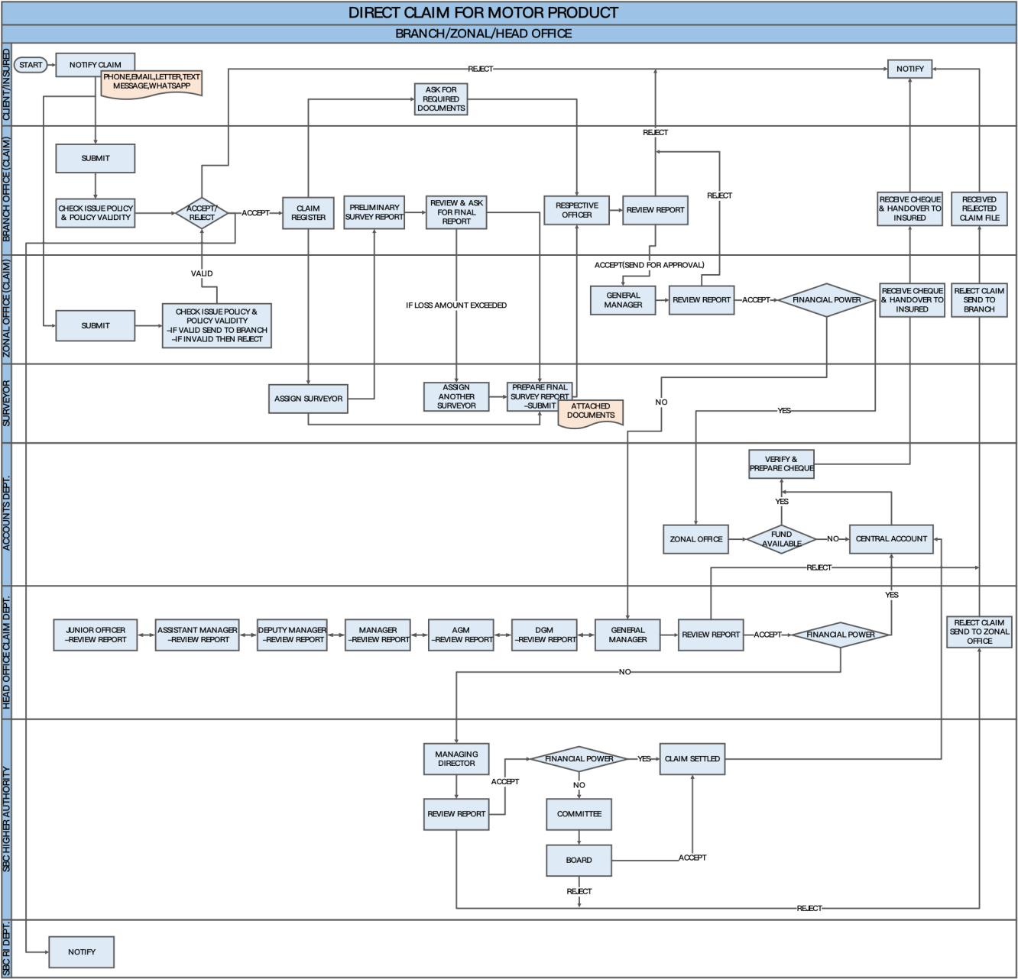

***Table18: Claim Workflow.***

1. The Client notifies the claim to the SBC’s Branch or Zonal Office (Claim Department) by phone, email, letter, text message and WhatsApp.
2. If the Client notify claim on Branch Office, then the branch office check issue policy and policy validity if valid then register the claim and if needed RI arrangement then branch office notify the claim SBC RI Department. if claim not valid then Branch Office reject the claim.
3. If the Client notify claim on Zonal Office, then the zonal office check issue policy and policy validity if valid then hand over the Claim to the Branch Office else reject the claim and report to the Client.
4. After claim register, Branch Office assigned to a Surveyor and simultaneously ask required documents from the client.
5. Then Surveyor do survey and provide a preliminary survey report to the Branch Office Claim Department.
6. The Branch Office Claim Department review preliminary survey report and ask to surveyor to submit the final survey report, if loss amount exceeded then claim department assigned another Surveyor.
7. Then both Surveyor jointly make the final report, and submit to the (Respective Officer) Branch office claim department.
8. The Branch Office Respective Officer review the report. If the claim is accepted then it sends to the zonal office General Manager for approval else reject the claim.
9. The Zonal Office General Manager review the report. If the claim is accepted then GM will check the claim settlement limit or financial claim power whereas the limit is payable it sends to the Zonal Office Account Department.
10. The Zonal Office Account will check fund available or not. If the Zonal Office Account fund is available then verify & prepare the cheque and send this to Zonal office claim department. Zonal office claim department received the cheque and send it to the branch office claim department. and branch office notify the client. Else, the Zonal Office Account fund is not available then request for fund in the SBC central account.
11. If the claim settlement limit is not payable then it sends to the Head office claim department General Manager. Then GM will send the claim report to the respective officer (Like DGM, AGM, M, DM, AM, JO) for reviewing report. Everyone reviews the claim report and send it to the GM again.
12. The General Manager review the report. If the claim is accepted then GM will check the claim settlement limit or financial claim power whereas the limit is payable it sends to the Central Account. SBC central account verify & prepare the cheque and send this to Zonal office claim department. Zonal office claim department send it to the branch office claim department and branch office notify the client.
13. If the claim settlement limit is not payable then it will send to the SBC Higher Authority (Managing Director).
14. The Managing Director review the report. If the claim is accepted then MD will check the claim settlement limit or financial claim power whereas the limit is payable it sends to the Central Account. SBC central account verify & prepare the cheque and send this to Zonal office claim department. Zonal office claim department received cheque and send it to the branch office claim department and branch office notify the client.
15. If the claim settlement limit is not payable then it will send to the Committee (Business Development Customer Service). Then Committee send it to the SBC Board of Director for claim settled.
16. . If SBC Board is accepted the claim, then it sends to the SBC Central Account. SBC central account verify & prepare the cheque and send this to Zonal office claim department. zonal office claim department received the cheque and send it to the Branch office. Then Branch office notify the client. If SBC Board is not accepted the claim, then it will send claim reject file to the head office claim department.
17. After that, Head office claim department send reject claim to the zonal office claim department. Zonal office claim department received claim reject file and send it to the branch office. Branch office notify the client.

# BCP(Billing Collection & Payment)

# Policy Documents

## Policy Summary (Schedule)

Summary of the details of policyholder, policy, and plan selected. Below elements would configure in the system in Risk Details.

***Table19: Policy Summary(Schedule).***

## Insurance Contract (Policy Wording)

This document indicates the contract between the policyholder and SBC.

## Debit Note